**Fruit Machine report/diagram**

|  |  |  |  |
| --- | --- | --- | --- |
| **Tests and Problems** | **Expected results** | **Actual Results** | **How did I fix it?** |
| **Image loading** | All 3 images should load and randomize | Only one image loaded | I accidentally capitalized a reference |
| **Spin button locking** | Button should lock when page first loads | I can still click spin on first open | I used a window.onload function to disable it until the player added a credit then it disabled this function. |
| **Credits being awarding when they shouldn’t** | Credits should only be awarded when 2nd and 3rd image are the same or all of them are | Sometimes the player one for no reason at all when no images are linked | The calculations for the winnings were off, i had to fix the array by making sure it calculated each image by a number correctly |
| ***Collecting*** | When you press the collect button it should go into your balance | It collected it but the balance went nowhere | I capitalized the reference so it was resetting the balance but sending it to an unknown const. |

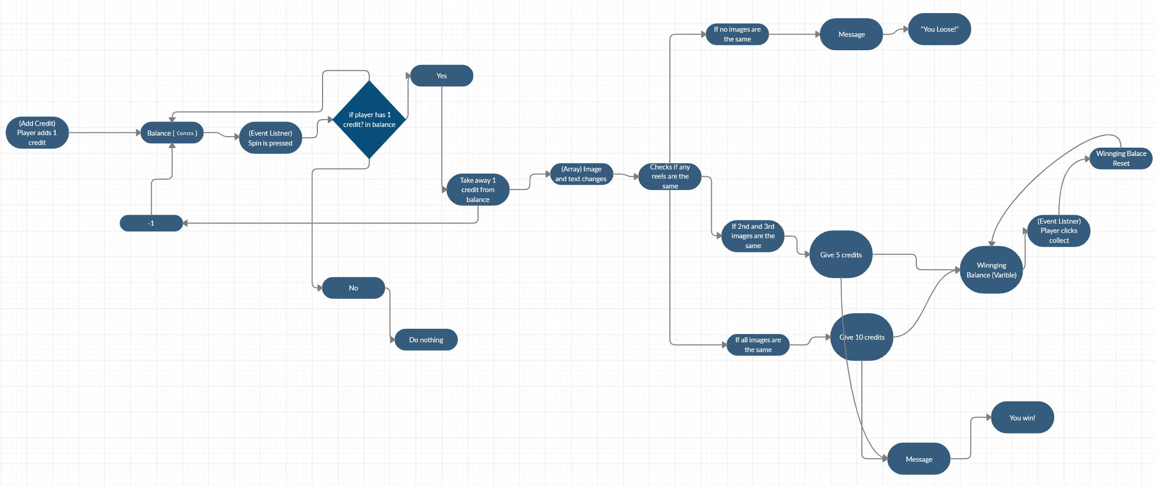

If image is hard to see this link should help <https://gyazo.com/48daa07c82b7a981cae84602b98e5373>

**Theatre Ticket report/diagram**

|  |  |  |  |
| --- | --- | --- | --- |
| **Tests and Problems** | **Expected results** | **Actual Results** | **How did I fix it?** |
| **Submit** | All details imputed should be calculated and outputted correctly | Everything but the calculations of cost was not submitted | I managed to get it to submit the value into pounds but not a exact value |
| **Method value** | It should calculate the method into the value it is set | Nothing | I managed to get a undefined answer with it converting to £ but no actual value |
| **Name wasn’t required** | It should not allow submission when you haven’t filled in some slots | You could submit anytime. | At the end of the html i did not put a /> which enabled the requirement. |
| ***Radio Button*** | You could click any of the buttons and it would know you have clicked that button | I couldn’t link the button to the java. | I managed to link the id to it in the end because I mispelled it. |

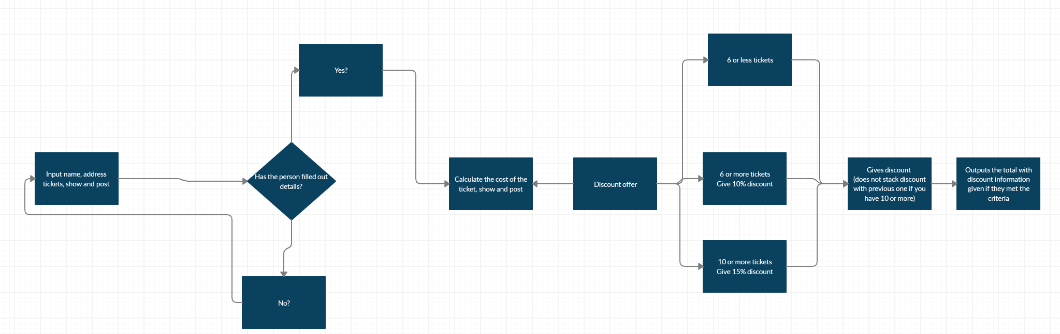

if image is hard to see this link should help

<https://gyazo.com/80eeed03e914d98fbcfb21b21ffff760>